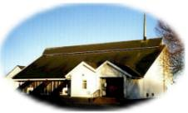

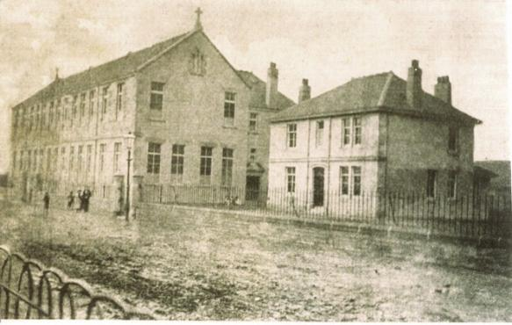

Old Chapel & School – Moorpark Road West

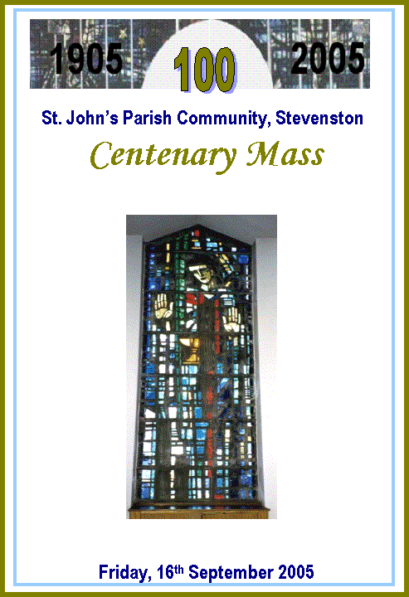

Thank you for joining us in the celebration of our Centenary Mass at St. John’s. We thank God for the Priests and Parishioners who have helped create and sustain our Parish Community.

As we celebrate this great milestone of our faith community, we pray that God will continue to fill us with His Spirit and enable us to journey forward, building up His Kingdom of justice, love and peace.

Fr. Martin Poland


2. My own belief in you, my Lord,
Is only a shadow of your faith in me;
Only a shadow of your faith in me;
Your deep and lasting faith.

3. My life is in your hands;
My life is in your hands.
My love for you will grow, my God.
Your light in me will shine.

4. The dream I have today, my Lord,
Is only a shadow of your dreams for me;
Only a shadow of all that will be;
If I but follow you.

5. The joy I feel today, my Lord,
Is only a shadow of your joys for me;
Only a shadow of your joys for me;
When we meet face to face.

Recessional Hymn: I Will Be With You

I will be with you wherever you go.
Go now throughout the world!
I will be with you in all that you say.
Go now and spread my word!

Come, walk with me on stormy waters.
Why fear? Reach out, and I’ll be there.

And you, my friend, will you now leave me,
Or do you know me as your Lord?

Your life will be transformed with power
By living truly in my name.

And if you say: ‘Yes, Lord I love you,”
Then feed my lambs and feed my sheep.

Lamb of God: Lamb of God, you take away the sins of the world.
Have mercy on us. Have mercy on us. (2)
Lamb of God, you take away the sins of the world
Grant us peace. Grant us peace.

Communion Hymn: Lord You Have Come To the Lakeside


1. Lord, you have come to the lakeside,
Seeking neither wealthy nor wise folk,
You only ask, Lord, that I should love you.

With love you have looked in my eyes, Lord,
Smiling gently, you called me by name;
And I left my boat by the lakeside,
Now with you I will seek other shores.

2. Lord, you well know that I carry
In my boat no treasure nor weapon.
I bring you only my willing labour.

3. Lord, you have need of my hands;
I shall labour that others may rest;
And from my love, Lord, may others love you.

4. Lord, other seas call me onward;
Hope eternal for hearts that are searching;
And love will bind us as friends for ever.

Post Communion Hymn: The Love I Have For You My Lord

1. The love I have for you, my Lord,
Is only a shadow of your love for me;
Only a shadow of your love for me;
Your deep abiding love.

Entrance Hymn: Oh The Word Of My Lord

Oh the word of my Lord, deep within my being,
Oh the word of my Lord, you have filled my mind.

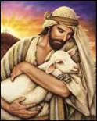
1. Before I formed you in the womb
I knew you through and through,
I chose you to be mine.
Before you left your mother’s side
I called to you, my child, to be my sign.

2. I know that you are very young,
But I will make you strong
- I’ll fill you with my word:
And you will travel through the land,
Fulfilling my command which you have heard.

3. And ev’rywhere you are to go
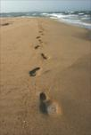
My hand will follow you;
You will not be alone.
In all the danger that you fear
You’ll find me very near, your words my own.

4. With all my strength you will be filled:
You will destroy and build.
For that is my design.
You will create and overthrow,
Reap harvests I will sow – your word is mine.

Rite Of Blessing & Sprinkling Holy Water

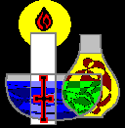

Gloria

Glory! Glory! Glory to God!
Glory! Glory! Glory to God!

Glory to God in the heights of the heavens,
Peace to God’s people, all people on earth.

Son of the Father, all glory and worship;
Have mercy on us, receive our prayer.

You take away the sin of the world,
Have mercy on us receive our prayer.

Seated in pow’r at the right of the Father,
Jesus alone is the Lord, the Most High.

And with the Spirit of love everlasting,
Reigning in glory for ever, Amen.

Liturgy Of The Word

1st Reading: Jeremiah 1:4-9

Responsorial I thank you for the wonder of my being
Psalm: I thank you.

2nd Reading: 2 Corinthians 5:14-20

Gospel Alleluia, Alleluia, Alleluia, Alleluia.
Acclamation:

Gospel: Matthew 28:16-20

Homily: (Canon John Walls)

Preparation of Gifts

(Procession of Gifts – including bread and wine, the holy oils to represent the sacramental life of the Parish, and our current book of prayers.)

Blessed Are You Lord God Of All Creation

1. Blest are you, Lord, God of all creation.
Thanks to your goodness this bread we offer;

Fruit of the earth, work of our hands,
It will become the bread of life.

Blessed be God! Blessed be God!
Blessed be God forever! Amen!
Blessed be God! Blessed be God!
Blessed be God forever! Amen!

2. Blest are you, Lord, God of all creation,
Thanks to your goodness this wine we offer:
Fruit of the earth, work of our hands,
It will become the cup of life.

Liturgy Of The Eucharist

Holy, holy, holy Lord, God of power and might,
Heaven and earth are full of you glory
Hosanna, hosanna, in the highest.
Blessed is He who comes in the name of the Lord,
Hosanna in the highest, hosanna in the highest.

Memorial When we eat this bread and drink this cup,
Acclamation: We proclaim your death Lord Jesus
Until you come in glory.

Great Amen; Amen, Amen, Amen, Amen Amen.

The Lord’s Prayer: Our Father…

